[ADA Compliance Handouts]

- Adding an “alt” tag to your images in Weebly
- Adding an “alt” tag to your images in Foxbright
- How to add closed caption in YouTube

Adding an “alt” tag to your images in Weebly

An “alt” tag (short for “alternative text”), is used to provide brief text descriptions of images that screen readers can understand and speak, allowing users to understand what it is.

Step 1. Click on your image

Step 2. Click on Advanced >

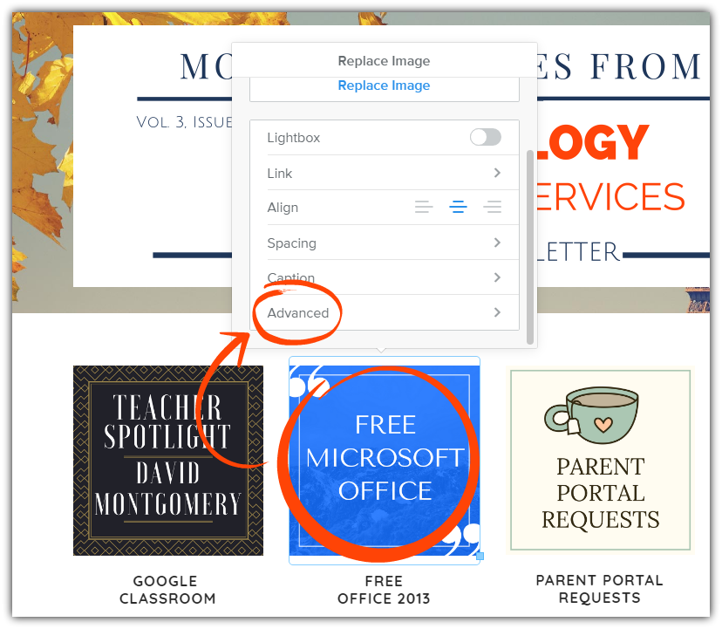

Step 3. In the Alt Text section, add text to describe your picture.

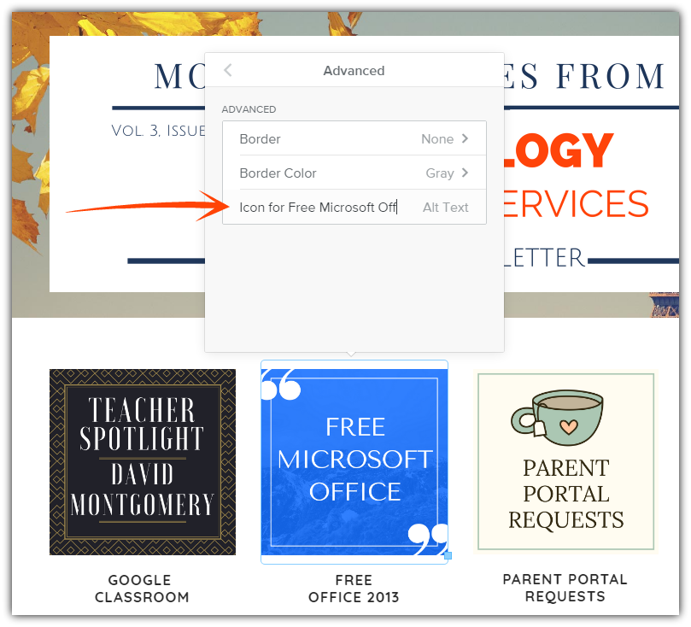

The words in the tag should be more than a description. They should provide a text equivalent of the image. In other words, the tag should include the same meaningful information that other users obtain by looking at the image. In the example of the Microsoft Office icon, adding an “alt” tag with the words “Icon for Free Microsoft Office” provides a meaningful description.

Step 4. Simply click away from the picture when finished

Step 5. Select Publish to save your changes to Weebly
Adding an “alt” tag to your images in Foxbright

An “alt” tag (short for “alternative text”), is used to provide brief text descriptions of images that screen readers can understand and speak, allowing users to understand what it is.

Step 1. Log into Foxbright & go to My Pages where your image displays

Step 2. Click Edit on your image block

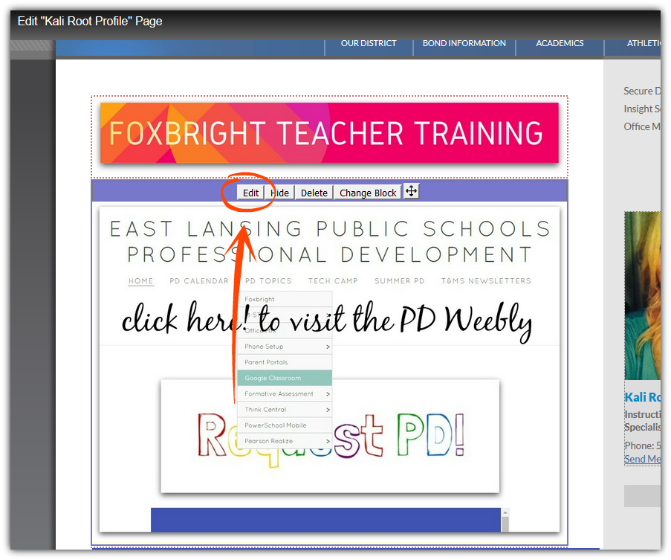

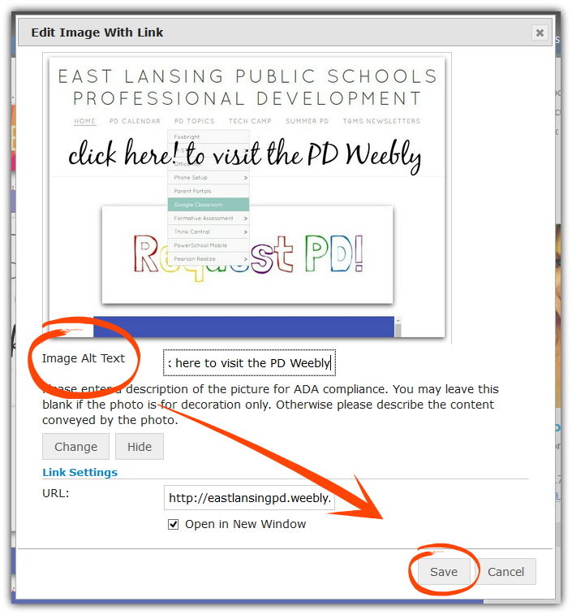
Step 3. Below the image, add a text description in Image Alt Text

The words in the tag should be more than a description. They should provide a text equivalent of the image. In other words, the tag should include the same meaningful information that other users obtain by looking at the image. In the example of the PD Weebly icon, adding an “alt” tag with the words “Icon Click here to visit the PD Weebly” provides a meaningful description.

Step 4. Click Save

Step 5. Select Publish to save your changes to Foxbright

