PowerTeacher Pro: Commonly Asked Questions

Below are 4 commonly asked questions related to entering grades into PowerTeacher Pro.

Please review the steps & screenshots or print the attached handout to reference as you enter grades. Pay close attention to where you should be entering comments!

If you would like further assistance, please contact Technology & Media Services.

1. Where do I enter grades?
2. How do I use auto-fill?
3. Where do I enter comments?
4. Where can I find the comment bank?
Where do I enter grades?
- Open PowerTeacher Pro
- Select Content area in section drop down
- Select the Grading tab in the left-hand menu
- Select Standards
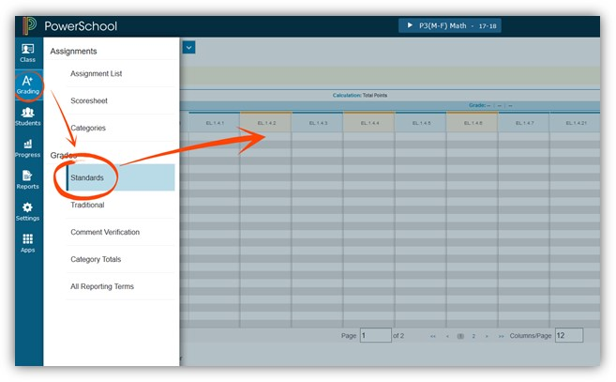

How do I use auto-fill?
➢ Select the Grading tab in the left-hand menu
➢ Select Standards
➢ Click in the first entry
➢ Enter a number
➢ Select auto-fill in the grey menu on the right-hand side of your screen
➢ Change individual grades as necessary
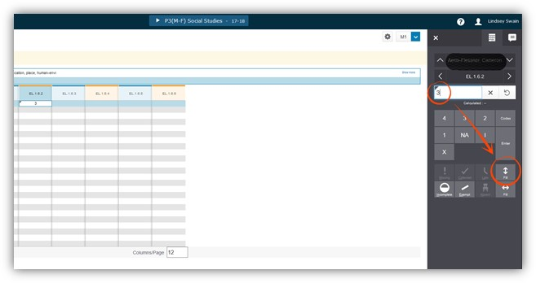

Where do I enter comments?
If you are a gen ed teacher…
➢ Go to your Homeroom section
➢ Select the Grading tab in the left-hand menu
➢ Select Standards
➢ Enter comments into the EL.CO.BE field
If you are a specials teacher…
➢ Go to each teacher section
➢ Select the Grading tab in the left-hand menu
➢ Select Standards
➢ Enter comments into the last field ex. EL.CO.PE
Note: Do not enter comments into the M1 field!
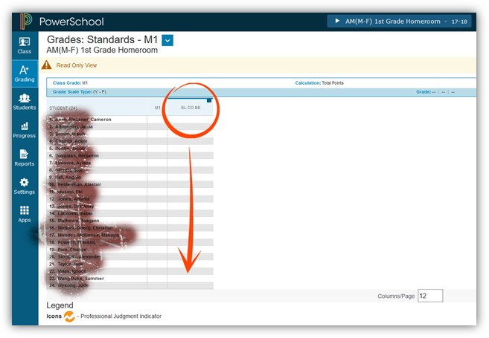

Where is the comment bank?
➢ Click into the comment field for the grey menu to appear on the right-hand side of your screen
➢ Click over to the comment bubble tab in the upper right-hand corner
➢ Select Comment Bank at the bottom of the menu
➢ Scroll through and select comment(s)
