Step 1. Go to www.elps.us
Step 2. Click STAFF links
Step 3. Click Technology Work Request (You may be prompted to enter your Microsoft username and password)
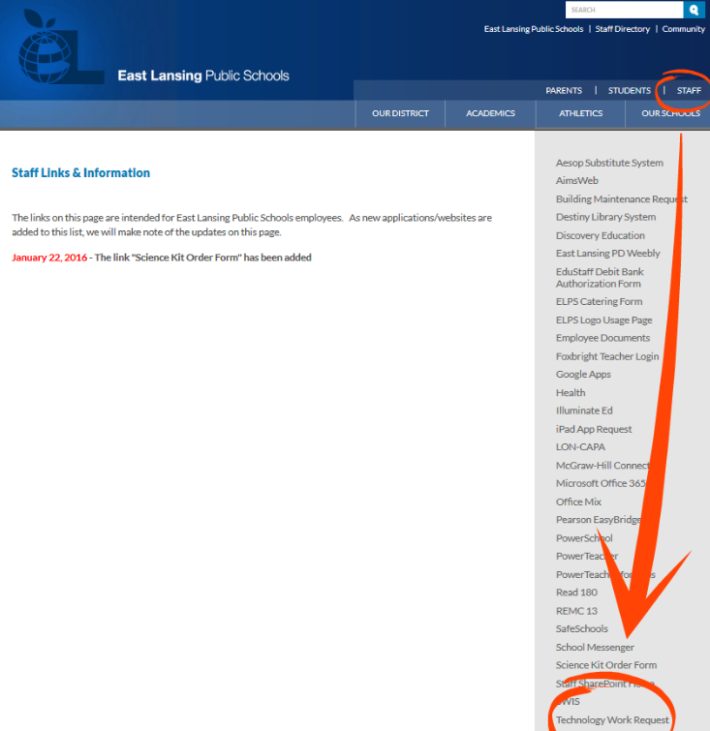

Step 4. Click New Technology Help Ticket
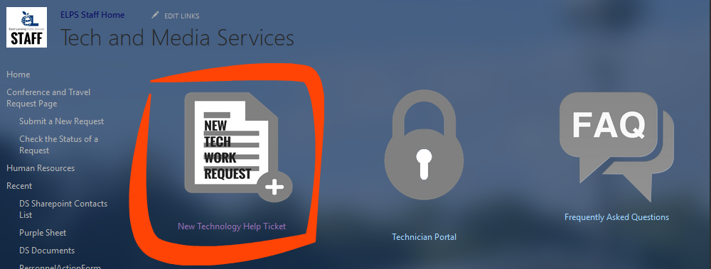

Step 5. Enter Name, Building Room number, Extension, Issue type, Subject, Description, Attachments
Step 6. Click Submit

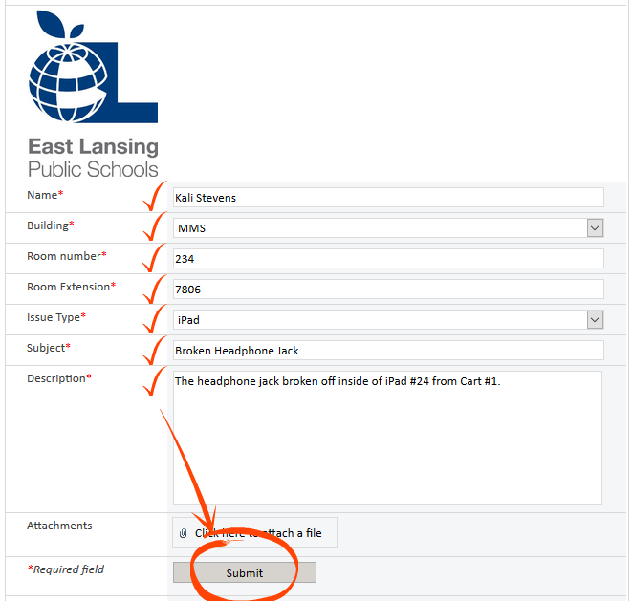

You will receive a confirmation email from ELPS Staff Home for each update made to your help request.
