**Dual Enrollment Approval Form: 14-17 Year-old Traditional Students**

Only Traditional Dual Enrolled students will complete this form. That is High School Advantage would NOT complete this form. Below are the steps the form takes in order to be completed:

1. The student clicks on the link for the dual enrollment form, taking them to the Dynamic Form.

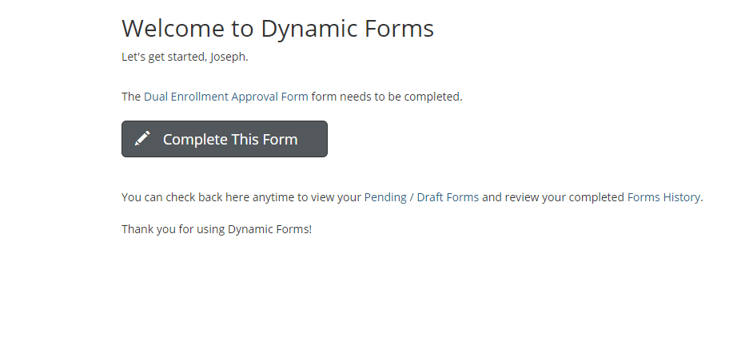

1. In this next step, the students are filling out their personal information (DOB, address, school name, anticipated graduation date), the classes they wish to sign up for, the class’s information (course type [Online, Online Real Time, Face to Face], start and end dates) and their parent’s information (name, email, phone number). They then sign it by clicking to sign and simply will type their name in.  They then go down to the bottom of the form (like the instructions under their signature line say to do) and submit. Everything with a red * must be completed and the form won’t let you submit without completing it (as you’ll notice, everything has the * on it except for the second line of CRNs and beyond as we can’t require them to sign up for two or more classes).
2. The students have to put the CRN of the specific course they want to register for as this is the only way for us to get permission to register them for it. The student also has to confirm the name of the course (this helps insure they put the right CRN), and also has to answer if they give permission to put in another course of the same type if that CRN is full. If the student selects “Yes,” and the course is full, we can then put them in a different section of the same course type (explained more later). If the student answers “No” and the class is full, they can’t be put in another section.

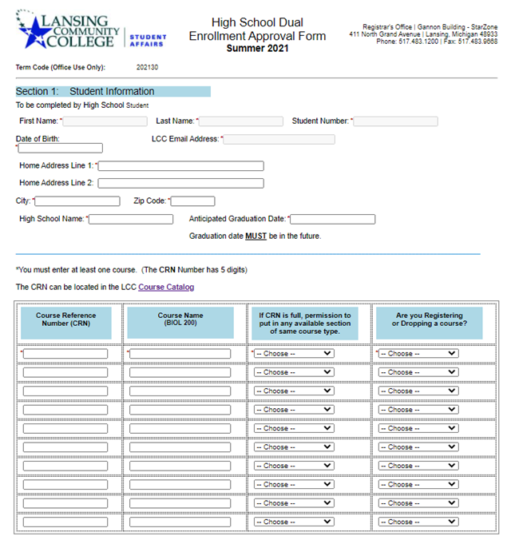

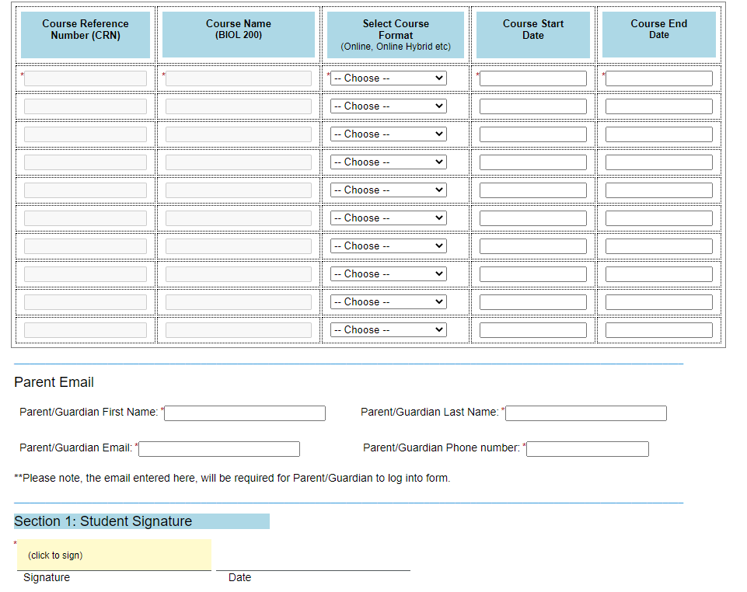

1. Once they submit the form, the STUDENT gets an email to their LCC email that looks like the email below:

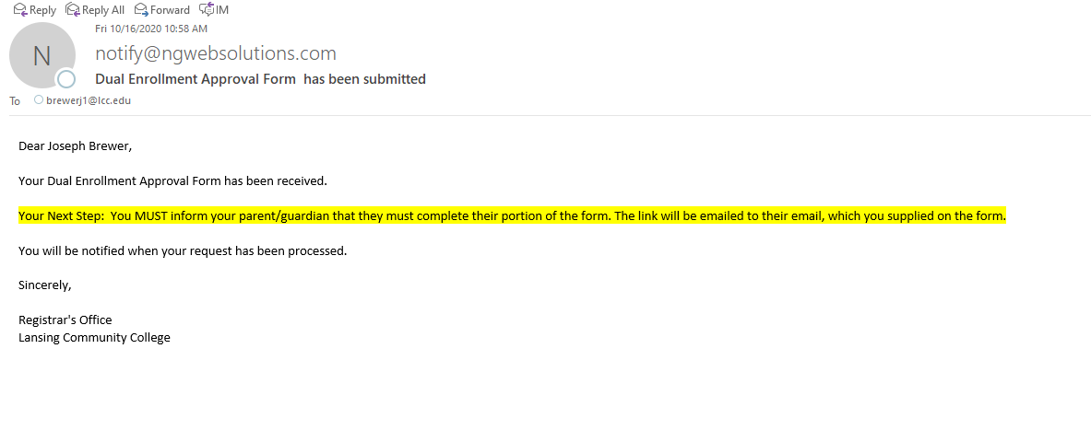

1. Here’s what the PARENT’S email looks like:

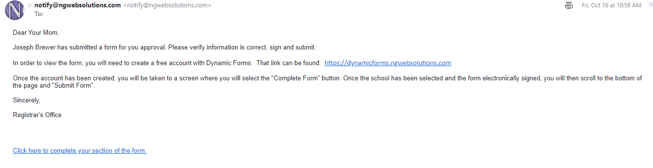

1. It is at this point that the PARENT must click “Click here to complete your section of the form” in order to fill out the form.  If the student is still logged in, there will be an error like the following: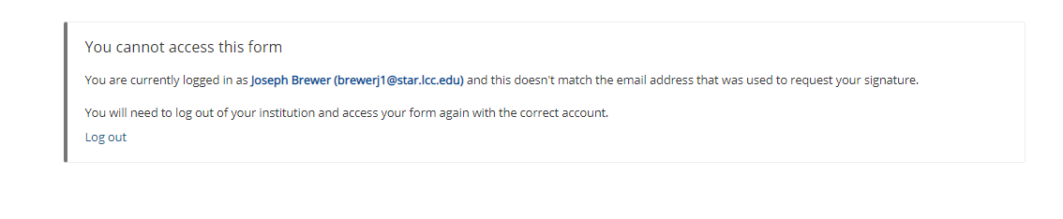
   1. The parent simply needs to click “Log Out” and it will log the student out. They will then need to go back to their email and click the link to fill out their section of the form.
2. It will then take them to the Log In page. They will either log in if they have an account or click “Create new Account.”  If they forgot their username or password, they can click on those links at this time as well.

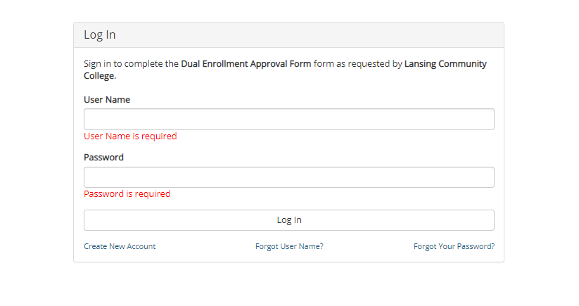

1. If they click on “Create New Account” they would see the following:

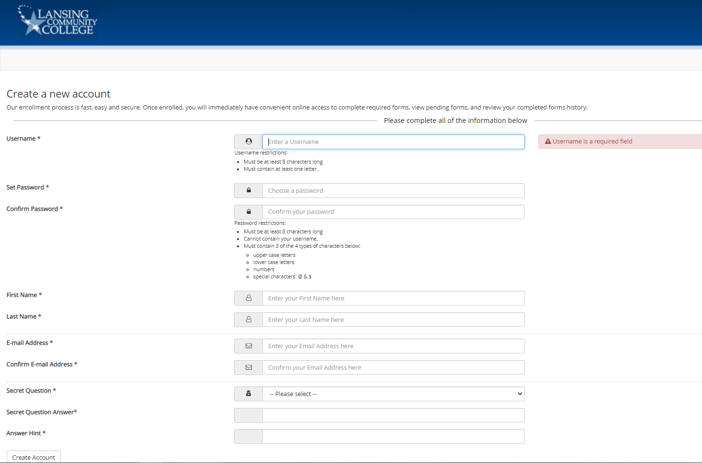

1. The parent simply needs to fill out all the information on the account creation page, and they will then be sent an email letting them know their account was created and they need to Activate it:

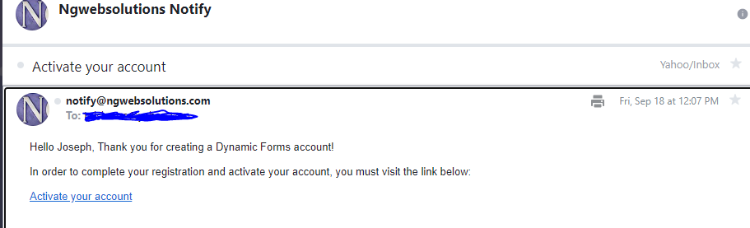

1. The parent will then need to click “Activate your account.”  This will make it so they can actually use it.  Now that they have done that, they need to go back to the ORIGINAL email with the link to complete the form, as they have yet to do that.  They will then log in with their newly created username and password, and see the following once they do:



1. After clicking “Complete this Form,” they will see everything the student filled out. They will then need to scroll down to the parent section (as they cannot edit the student’s section) and fill out their information. They will select if the classes are for the summer or if they are self-paying for them. If the courses are not for summer, or if the parent/guardian is not self-paying, they will then click on the “School District Responsible for Payment” section, as that’s who is paying/approving for the classes.  They then click to sign, type their name, and scroll down to the bottom and click submit:

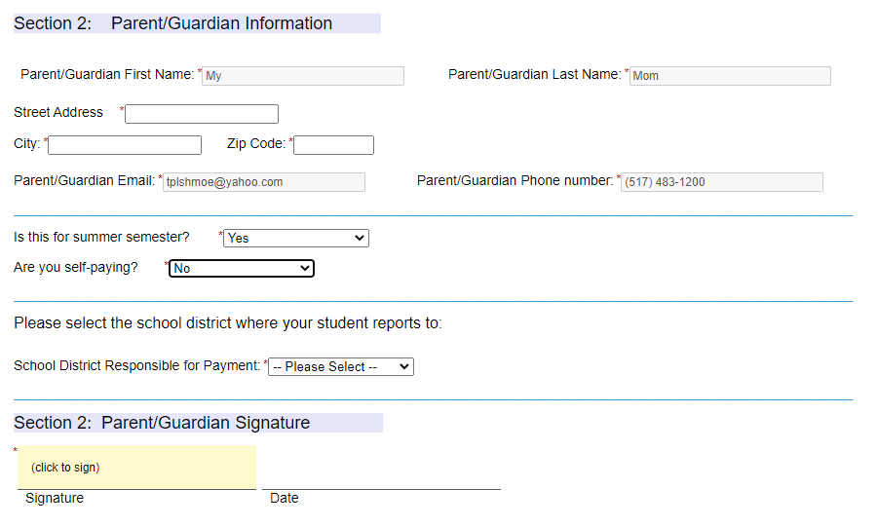

1. Once the parents submit the form, an email is sent to the high school they selected was responsible for payment. They will receive an email just like the parent’s email, instructing them to complete the form. If the high school has not made a username with Dynamic Forms, they are to follow the exact same steps the parent followed. Once they have their account, they have to complete their section of the form.

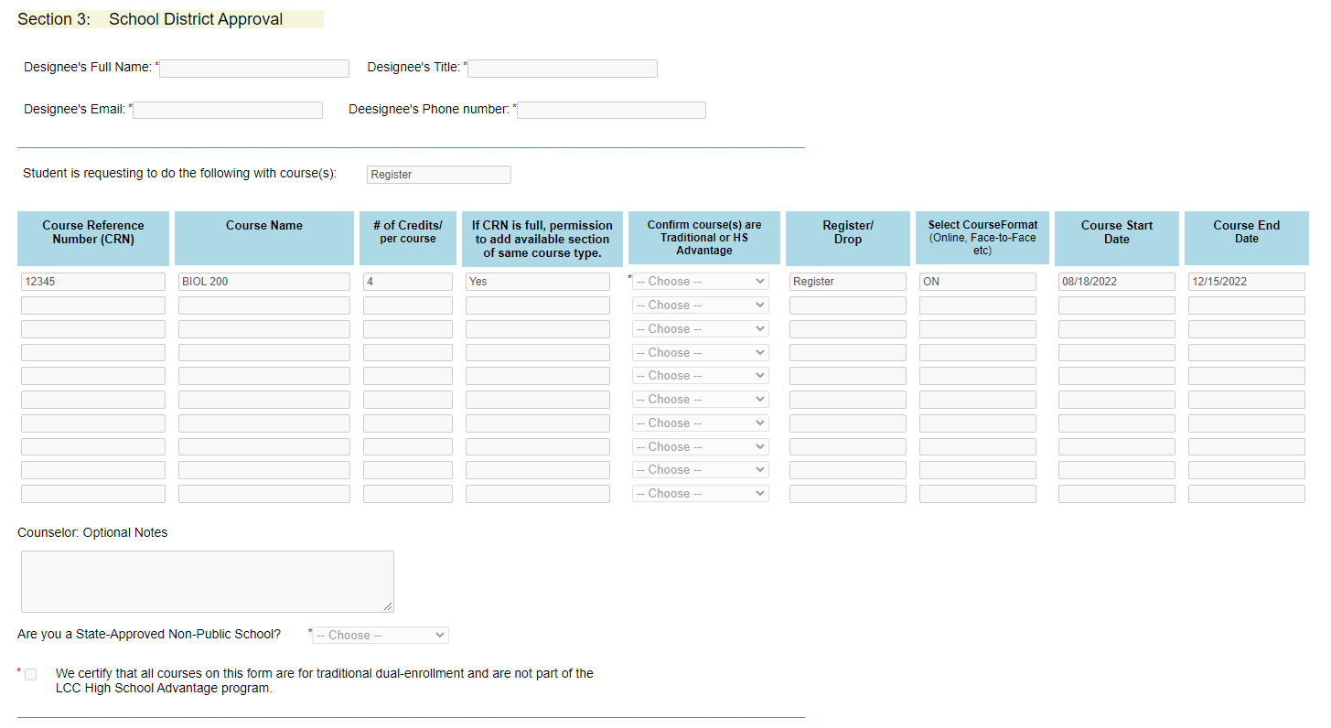

1. Some schools do both Traditional and High School Advantage courses, but the students may be confused as to which courses they are taking as a “Traditional” student and which ones as a “High School Advantage” student. For this reason, counselors have a dropdown box next to each course where they must approve the course as a “Traditional” course. If the student selected a course that is not traditional, the counselor would label that specific course as High School Advantage; this allows us to still use the one form and not make the student resubmit. They must also check a box indicating that the classes being approved are traditional dual enrollment and are not part of LCC’s High School Advantage (NOTE: it’s important to mention that it’s “LCC’s” High School Advantage as some high school’s refer to their individual programs as High School Advantage).
   1. If the high school selects “High School Advantage” or “Denied” for any course, we will not register the student for that course; even if it’s not an actual high school advantage course, we use this same drop down for denying a course to make things simple right now.
2. After the school approves the individual classes, they must then complete their payment section. The schools are asked if they are a Non-Public School or not, as Non-Public (private) schools fill out different invoicing information. The school’s invoicing information will then need to be completed based on how they answer that question.
3. Once the school submits, an email is sent to the dual enrollment email that there is a form for LCC to complete. Once LCC adds the student to their course, an email will be sent to the student’s LCC email to alert them that their form has been processed or denied. The email will include the status of “registered” or “denied” for each class the student put on their form. If denied, it will say why it was denied as well.
   1. NOTE: If putting multiple classes down, and the student was only able to get into one course, the form would still be approved as we could get them into something. The email sent to the student would tell them which courses they were registered for and which they weren’t. The student should report this back to their counselor.
   2. It is the student’s responsibility to know what classes they are registered for.

**How can I check on a past dual enrollment form I signed?**

*The following steps can be done by the parent/guardian or the high school*

1. You can log back into Dynamic Forms at any time to check on any form that you have already signed. A quick link to Dynamic Forms can be found here: <https://dynamicforms.ngwebsolutions.com/Account/Login>

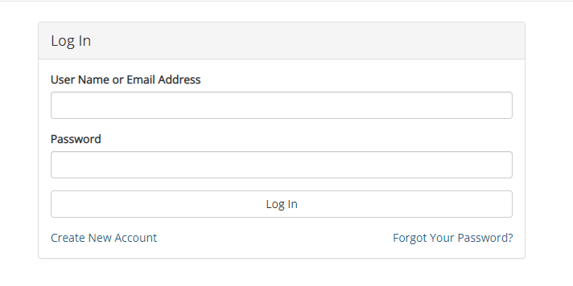

1. You will use the same username and password that was used to sign the Dynamic Form initially. In the upper right corner, select “My Forms.” From here you can either click on all currently pending forms (ones you haven’t signed yet) or “Forms History” to see past forms. Select “Forms History” to look up old forms.

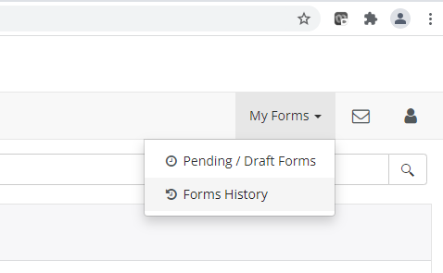

1. From here, you can sort by the student’s name (Form Started By) or by the date it was signed on (E-Signed Date). Select the “PDF” icon to view the form. Form here, you can see every step the form has gone through, as well as the outcome (including the approval/denial comments results).